**Pedal by wire**

**Introduction :**

Throttle-by-wire, or accelerate-by-wire, was the first type of drive-by-wire system

These systems use a pedal unit and an engine control unit (ECU) .

The pedal uses sensors that measure how much or how little the driver moves the accelerator, and the sensors send that information to the ECU.

**How it works :**

The controller (ECU ) takes power from the batteries  and delivers it to the motor . The accelerator pedal hooks to a potentiometers  (variable resistors), and this potentiometer provides the signal that tells the ECU how much power it is supposed to deliver.

The controller can deliver zero power (when the car is stopped), full power (when the driver floors the accelerator pedal), or any power level in between.

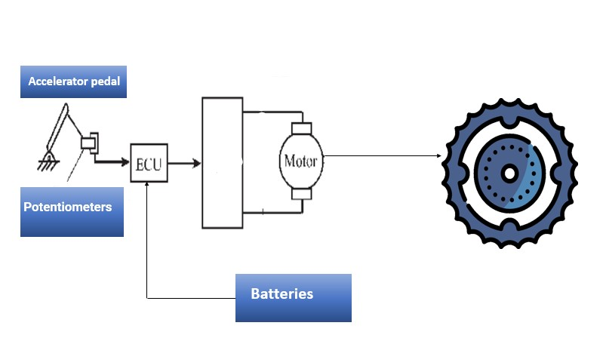

When you push on the gas pedal, a cable from the pedal connects to these two potentiometers:

The signal from the potentiometers tells the controller how much power to deliver to the electric car's motor. There are two potentiometers for safety's sake. The controller reads both potentiometers and makes sure that their signals are equal. If they are not, then the controller does not operate. This arrangement guards against a situation where a potentiometer fails in the full-on position

What we need ?

Batteries / converter DC / AC / potentiometters / pedal

References

<https://www.amazon.com/Kunray-Brushless-Electric-Controller-Motorcycle/dp/B09622N8RV>

[https://www.amazon.com/X9C103S-Digital-Potentiometer-Module-Arduino/dp/B01N4KIQ34](https://l.facebook.com/l.php?u=https%3A%2F%2Fwww.amazon.com%2FX9C103S-Digital-Potentiometer-Module-Arduino%2Fdp%2FB01N4KIQ34%3Ffbclid%3DIwAR3PwmeU87JojAPgMzD25affwnWQClthv6B_smFZdmbJSqqScgIpRn6bhiw&h=AT32NmVUVyV_DRjIKhrz4DK75JKp4bLZPJwlqdCm4U4SfFM2fJvSgU8gsMqw6f5EMH_j47XMfLzZHJHgKJCh-c46mcschQ1k8xp45-KNfQBp5ECXMVI40lPr1C43iMFfaGIswQ)